**Honors PreCalc**

**Unit 2 Quiz 1 Review**

**U2LT2 I can find a function relative and absolute max/min as well as intervals in increase, decrease and constant.**

Find the increase, decrease, constant, max and min of each functions.

1.  2.  3. 

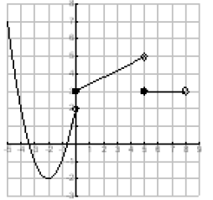

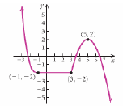

4. 5.

5. Given the following graph the function:

Function that increasing on the interval (-6, -2) ,

constant at (-2, 5) and increasing at (5, ∞).

Name a point where the graph is increasing.

Name a point where it is constant.

Name a point where it is decreasing.

**L2LT2 I can identify if a function is continuous or not. I can state the type of discontinuity if one is found.**

6.  7.  8.  9. 

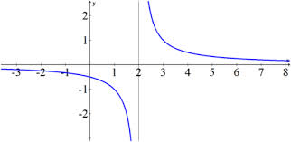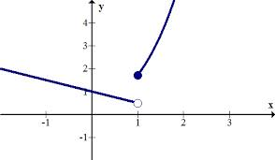10. 11.

**U2LT3 I can describe a function’s end behavior using limit notation.**

**State the end behaviors of the functions.**

**12. $f\left(x\right)=\frac{x-2}{x+4}$ 13. $f\left(x\right)=-5x^{4}+6x^{2}-7$**

**14. $f\left(x\right)=\frac{5x}{x^{2}-4}$ 15) $f\left(x\right)=\frac{3x}{x^{2}+1}$**

**16. $g\left(x\right)=-3x^{3}+2x+1$ 17. $h\left(x\right)=x^{5}+10x-7$**

**18. $f\left(x\right)=4x^{4}+3x^{2}-6x$ 19. $g\left(x\right)=-3x^{200}+4x-7$**