Rational Graph HW Day 1
State the domain of the function, identify all intercepts, find any asymptotes or holes, and plot additional solution points as needed to sketch the graph of the rational function.
1. $f\left(x\right)=\frac{1}{x-3}$ 2. $f\left(x\right)=\frac{1}{6-x}$

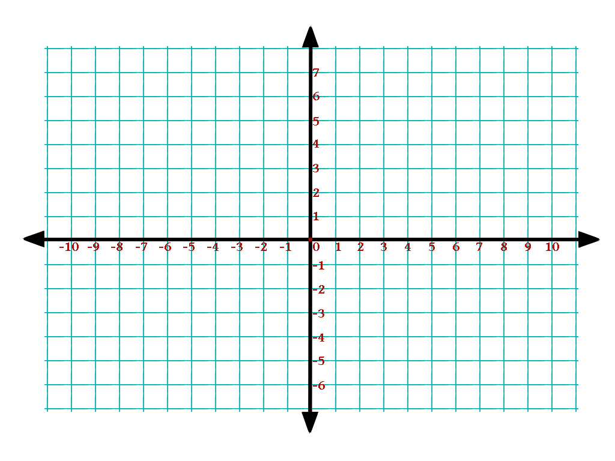

3. $f\left(x\right)=\frac{1-3x}{1-x}$ 4. $f\left(x\right)=\frac{x^{2}-2x-8}{x^{2}-9}$

5. $f\left(x\right)=\frac{x^{2}-36}{x+6}$ 6. $f\left(x\right)=\frac{x^{2}+5}{x}$

