5.2 Finding Zeros of Polynomials
IF.5 I can find the ‘zeros’ of polynomial functions
What is a polynomial function?

Standard Form
Factored Form

ZEROS OF A POLYNOMIAL FUNCTION
Other Names for Zeros:

Finding zeros on a graph of a polynomial function:
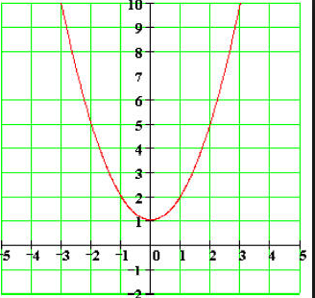
Zeros are the _____________ where ___________________.
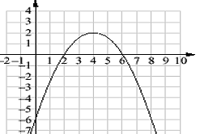
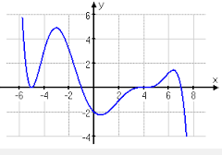

Zeros:

X-intercepts:
Zeros:

X-intercepts:
Zeros:
x =
x =
X-intercepts:

Factors, Roots, Zeros
Example: $x^{2}+2x-15$
- Solve by setting each factor = 0
- Factor
- Write Equation

Remember! Only ONE factor needs to be zero in order for the product to be zero.
Let’s work on just the “solving” part. Here we are finding the zeros of the polynomial algebraically.
Try These:

- $x\left(x-2\right)=0$

- $3(x+4)=0$

- $4x\left(x+1\right)=0$

- $\left(x-5\right)\left(x+8\right)=0$

- $\left(x+6\right)\left(x-4\right)\left(x+3\right)=0$

- $x\left(x+2\right)\left(x-2\right)=0$

- $3x\left(4x+5\right)=0$

- $\left(6x-1\right)\left(7x+3\right)=0$

- $\left(10x+13\right)\left(3x-1\right)\left(x+2\right)=0$

- $4x\left(x+8\right)\left(2x-3\right)=0$

Bonus! If you were to graph these polynomials, what would the x-intercepts be?

1)
2)
3)
4)
5)
6)
7)
8)
9)
10)

