Algebra 3-4 Name:______________________________
IF.4 I can factor special quartic polynomials Period:_______________________
Directions: FACTOR each polynomial . DO NOT SOLVE THE EQUATION.
DO ALL WORK ON A SEPARATE SHEET OF PAPER PLEASE.
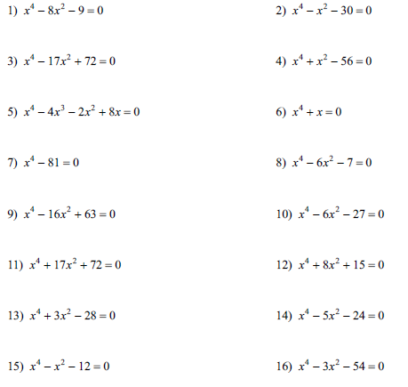

17) $x^{4}-14x^{3}+45x^{2}$ 18) $2x^{4}+10x^{3}-48x^{2}$

19) ${2x}^{4}+3x^{3}-27x^{2}$ 20) ${5x}^{4}+19x^{3}+12x^{2}$

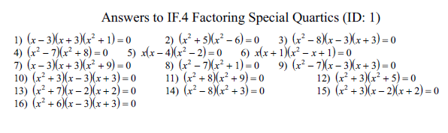

17. $x^{2}\left(x-5\right)\left(x-9\right)$
18. $2x^{2}\left(x+8\right)\left(x-3\right)$
19. ${2x}^{2}\left(2x+9\right)\left(x-3\right)$
20. $x^{2}\left(5x+4\right)\left(x+3\right)$

